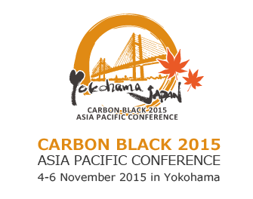
4-6 November 2015, Yokohama * The Yokohama Bay Hotel Tokyu

SPONSORSHIP CONFIRMATION

NAME
COMPANY
DEPARTMENT
E-MAIL
PHONE

Please tick (✓ ) to select the SPONSORSHIP package.

PLATINUM JPY1,000,000-
(includes 3 FOC(free of charge) Conference Pass)

× Welcome Dinner, Wednesday 4 November 2015 (Not Available. Sponsorship secured)

× Thumb drive (Not Available. Sponsorship secured)

× Lanyard (Not Available. Sponsorship secured)

× Congress Bag (Not Available. Sponsorship secured)

GOLD JPY750,000-
(includes 2 FOC Conference Pass)

× Networking Lunch, Thursday 5 November 2015 (Not Available. Sponsorship secured)

× Networking Lunch, Friday 6 November 2015(Not Available. Sponsorship secured)

□ Morning Coffee Break, Thursday 5 November 2015

□ Afternoon Coffee Break, Thursday 5 November 2015

□ Morning Coffee Break, Friday 6 November 2015

□ Afternoon Coffee Break, Friday 6 November 2015

SILVER JPY500,000-
(includes 1 FOC Conference Pass)

× Bottled Drinks, Thursday 5 November 2015(Not Available. Sponsorship secured)

× Bottled Drinks, Friday 6 November 2015(Not Available. Sponsorship secured)

STANDARD JPY350,000-
(includes 1 FOC Conference Pass)

Please note:

- Confirmation is only accepted after full payment is received.
- Sponsorship if FINAL, no refund after payment made.

Upon your confirmation, kindly sign this form and reply via email to:
cb2015reg@ech.co.jp

_____________________________ ________________
Signature Date

